Hyperactivity Intervention Option 2: Self-Management
Self-management as an intervention for hyperactivity is a process in which children monitor their own activity level, record the results, and compare this level to a predetermined, acceptable level of activity. The goal of self-management is for the child to become aware of his or her own level of activity in order to produce an automatic response without relying on external reinforcement or prompting. A child's ability to produce this automatic response through internalized controls can decrease his or her situation-specific, inappropriate overactivity. The procedural steps for incorporating self-management strategies into the treatment of hyperactivity are summarized below.
Procedural steps for the application of self-management of hyperactivity
1. Teach self-monitoring procedures to the child.
a. Identify the problem behavior and the new behavior to replace it.
b. Model the replacement behavior, and indicate the level (i.e., the frequency and/or intensity) at which it should occur.
c. Role-play the expected level and behavior with the child.
d. Ask the child and the person modeling the behavior (e.g., teacher) to record either a plus (+), indicating appropriate activity level, or a minus (-), indicating overactivity.
e. Compare both sets of ratings.
f. Provide reinforcement for accurate child recordings.
g. Continue this process until the child masters self-recording (i.e., typically with 90% accuracy).
2. Determine if the replacement behavior is happening in the desired setting.
3. As needed, prompt the child to monitor activity (e.g., a beep on a tape recorder).
4. Ask the child to self-record the occurrence of the replacement behavior.
5. Graph the occurrence of the replacement behavior in order to demonstrate success or failure of the targeted behavior and activity level.
6. Provide consistent feedback and appropriate reinforcement.
Considerations When Implementing a Self-Management Intervention Strategy
For Teaching. When teaching children to self-manage, it is important to thoughtfully consider the goal of the intervention. If the objective is to reduce fidgety behaviors, the intervention and outcome will be different than improving a class of behaviors, such as listening or assignment completion. For example, targeting fidgety behaviors may result in solely monitoring and recording the tapping of a foot or pencil, which may not produce the same results that monitoring on-task behavior or task completion might.
However, reducing fidgety behaviors may be the primary goal in other situations. For example, if a student's behavior interrupts the other students' class work or creates a negative relationship with the teacher, it may be best to focus on reducing those behaviors, even if the student's overall academic performance is not targeted and, therefore, does not improve. Research Studies Supporting Use of Self-Management Intervention Strategies The following studies support the use of self-management intervention strategies for dealing with hyperactivity problems. Detailed annotations of these studies are included in the BASC-2 Intervention Guide.
Christie, D. J., Hiss, M., & Lozanoff, B. (1984). Modification of inattentive classroom behavior: Hyperactive children's use of self-recording with teacher guidance. Behavior Modification, 8(3), 391-406. Horn, W. F., Chatoor, I., & Conners, C. K. (1983). Additive effects of Dexedrine and self-control training. Behavior Modification, 7,(3), 383-402.
Kern, L., Ringdahl, J. E., Hilt, A., & Sterling-Turner, H. E. (2001). Linking self-management procedures to functional analysis results. Behavioral Disorders, 26(3), 214-226.
Varni, J. W., & Henker, B. (1979). A self-regulation approach to the treatment of three hyperactive boys. Child Behavior Therapy, 1(2), 171-192.

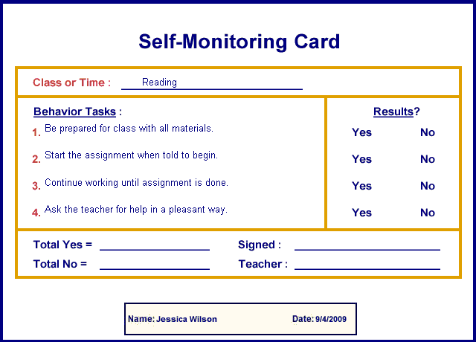
Self Monitoring Card for _________________
Date__________
Class or Time:
Behavior Tasks:  1.  2.  3.  4. | Results:  Yes No  Yes No  Yes No  Yes No
Total Yes=__________ Student Signature_______________________

Total No=__________ Teacher Signature_______________________

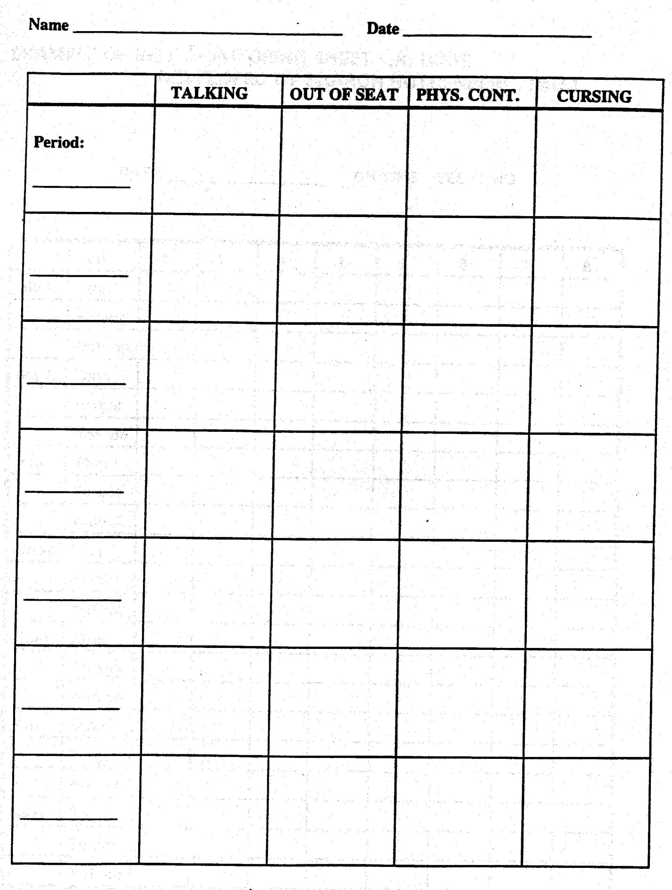
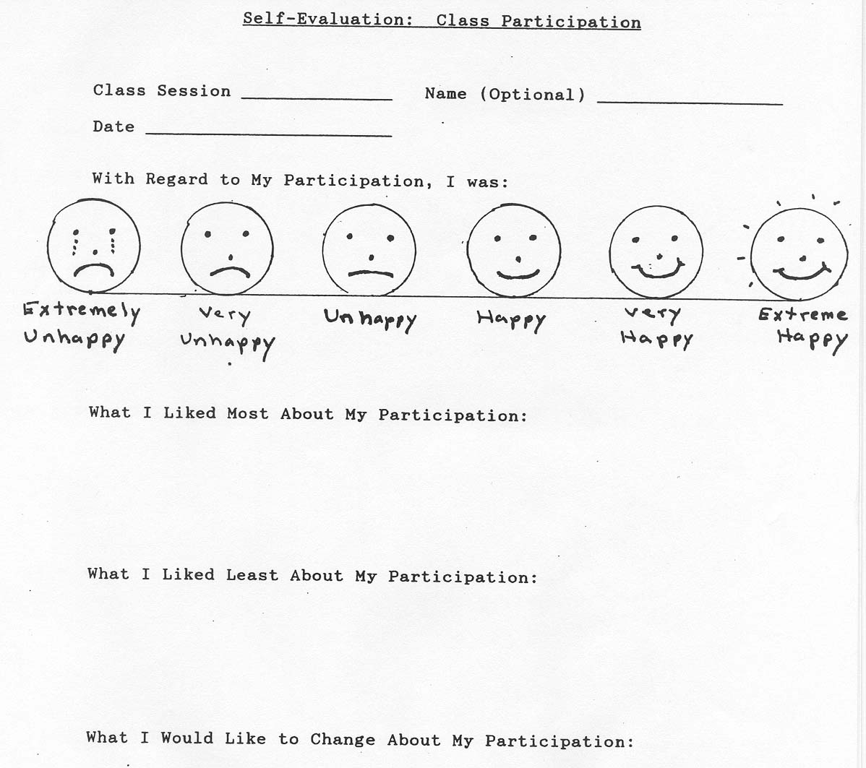

Self Monitoring Contract
Student Name: Date:
Teacher: Class:
Definition of behavior to monitor:

Over what time:

What do you get if criteria are met?

What do you lose if the criteria are not met?

Optional Bonus Clause:

Signature of Student:____________________________________
Signature of Teacher:___________________________________
Comments:

